# CHAPTER 1

## INTRODUCTION

In a world of increasing misdirection by journalists in a race to attain more clicks, we are trying to make an open source, moderated platform to bring together the latest sport articles. This sports blog is maintained by a community of true sports enthusiasts who have a real passion to share information about sports.

Sports Blog is a static blog page that is designed to share information on sports and more. This project aims at maintaining all the latest information in the world of sports, every article added is a huge gift to a normal person looking to catch up with the news in the world of sports. Aim is to provide transparency in this field, make the process of sharing of articles hassle free and corruption free and make the world of journalism effective.

# CHAPTER 2

## REQUIREMENT SPECIFICATION

A high-level requirements specification is required. The purpose of the requirements analysis is to identify requirements for the proposed system. The emphasis is on the discovery of user requirements.

### 2.1 SOFTWARE REQUIREMENTS

Operating System : Any operating system with a browser.

Tools : GIT, Jekyll

### 2.2 HARDWARE REQUIREMENTS

Processor : Any Processor above 500 MHz

RAM : 4GB

Hard Disk : 2 GB free space

Input device : Keyboard, Mouse

Output device : Monitor

System type : 32-bit or 64-bit operating system

### 2.3 FUNCTIONAL REQUIREMENTS

**Home page:** Home page is the first page of the website. Home page contains the links to all the different sports and a little information about the blog

**Blog Page:** In this page, all the articles can be viewed.

**Ranking:** Top athletes and teams in various sports can be found ranked here.

### 2.4 NONFUNCTIONAL REQUIREMENTS:

### PERFORMANCE:

Performance requirements define acceptable response times for system functionality.

* The load time for user interface screens shall take no longer than 5 seconds.

### RELIABILITY:

* Avoid incorrect storage of records.

### SECURITY:

* HTTPS connection.

### FLEXIBILITY:

* The system keeps on updating the data with very little delay.

### MAINTAINABILITY:

* GitHub is very reliable and requires almost no maintenance.

# CHAPTER 3

## OBJECTIVE OF THE PROJECT

The main objective of this application is to automate the complete operations of the blood bank. They need maintain hundreds of thousands of records. Also searching should be very faster so they can find required details instantly.

To develop a web-based portal to facilitate the co-ordination between supply and demand of blood. This system makes conveniently available good quality, safe blood and other blood components, which can be provided in a sound, ethical and acceptable manner, consistent with the long-term well-being of the community. It actively encourage voluntary blood donation, motivate and maintain a well-indexed record of blood donors and educate the community on the benefits of blood donation. This will also serve as the site for interaction of best practices in reducing unnecessary utilization of blood and help the state work more efficiently towards self-sufficiency in blood.

The system will provide the user the option to look at the details of the existing Donor List, Blood Group and to add a new Donor. It also allows the user to modify the record. The administrator can alter all the system data.

# CHAPTER 4

## SYSTEM DESIGN

### 4.1 FLOW OF WEB PAGES

A use case diagram at its simplest is a representation of a user's interaction with the system that shows the relationship between the user and the different [use cases](https://en.wikipedia.org/wiki/Use_case) in which the user is involved. Figure 4.1 below shows the use case diagram for this website.

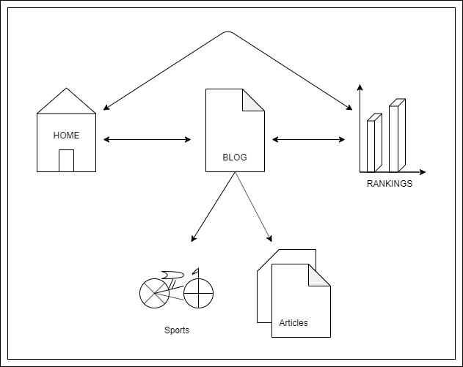

**Figure 4.1: Flow of Web Pages**

# CHAPTER 5

## IMPLEMENTATION

### 5.1 SOURCE CODE

# CHAPTER 6

## TESTING

This chapter gives the outline of the testing methods that are carried out to get a bug free system. Quality can be achieved by testing the product using different techniques at different phases of the project development. The purpose of testing is to discover errors. Testing is the process of trying to discover every conceivable fault or weakness in a work product. It provides a way to check the functionality of components sub assemblies and/or a finished product. It is the process of exercising software with the intent of ensuring that the Software system meets its requirements and user expectations and does not fail in an unacceptable manner. There are various types of test. Each test type addresses a specific testing requirement.

### 6.1 TESTING PROCESS

Testing is an integral part of software development. Testing process certifies whether the product that is developed compiles with the standards that it was designed to. Testing process involves building of test cases against which the product has to be tested.

### 6.2 TESTING OBJECTIVES

The main objectives of testing process are as follows.

* Testing is a process of executing a program with the intent of finding an error.
* A good test case is one that has high probability of finding undiscovered error.
* A successful test is one that uncovers the undiscovered error.

**Table 5.1: Test cases**

|  |  |  |  |  |
| --- | --- | --- | --- | --- |
| **S.NO** | **CASE** | **INPUT** | **EXPECTED OUTPUT** | **ACTUAL OUTPUT** |
| 1 | Registration | Blank Field | Submission unsuccessful | Submission unsuccessful |
| 2 | Admin Login | Username and password | Admin  Home page | admin Home page |
| 3 | Admin Login | Wrong Username or password | Submission unsuccessful | Submission unsuccessful |
| 4 | Donor Registration | Blank | Please fill out the fields | Please fill out the fields |
| 5 | Donor Email Id | Donor Name | Enter Email Id | Enter Email Id |
| 6 | Donor Login | Blank | Please fill out the fields | Please fill out the fields |
| 7 | Donor Login Email | User Name | Please Enter the Email id | Please Enter the Email id |
| 8 | Donor Login | Wrong User Name and Password | Invalid User Name and Password | Invalid User Name and Password |
| 9 | Search Blood | Blood Group | Open selected Blood group donor list | Open selected Blood group donor list |
| 10 | Request Blood | Blank | Please fill out the fields | Please fill out the fields |

# CHAPTER 7

## RESULTS

This section describes the screens of the “Blood Bank Management System”.

The snapshots are shown below for each module.

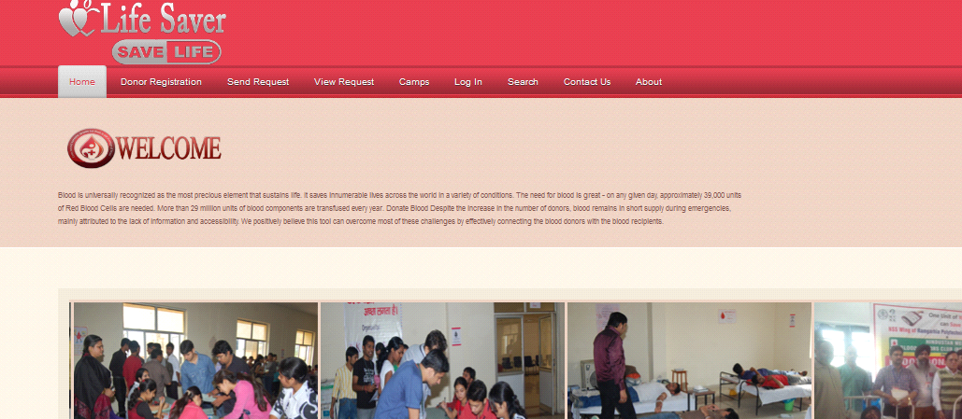

### Figure 7.1: Home page

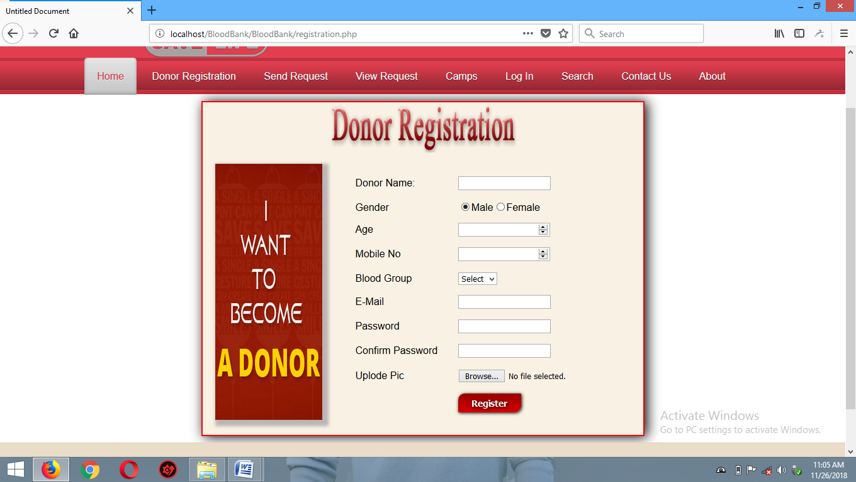

### Figure 7.2: Donor Registration page

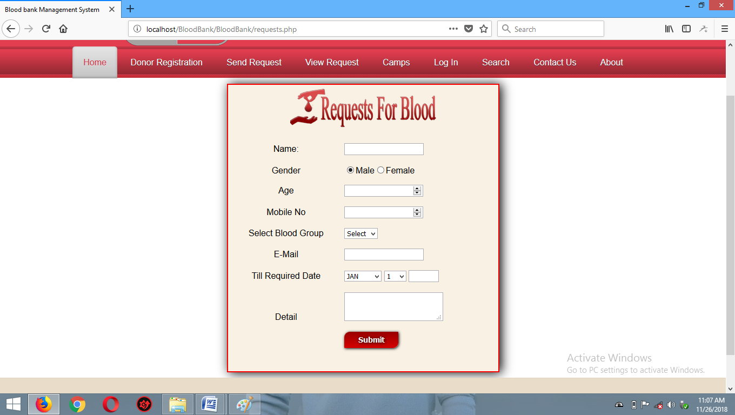

### Figure 7.3: Request For Blood

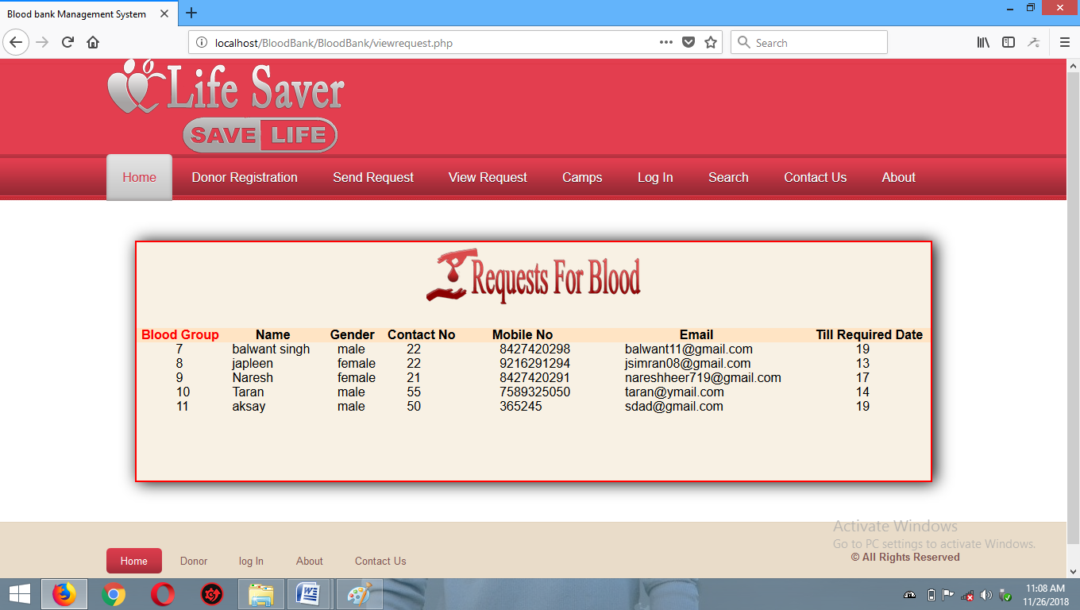

### Figure 7.4: Requested List Page

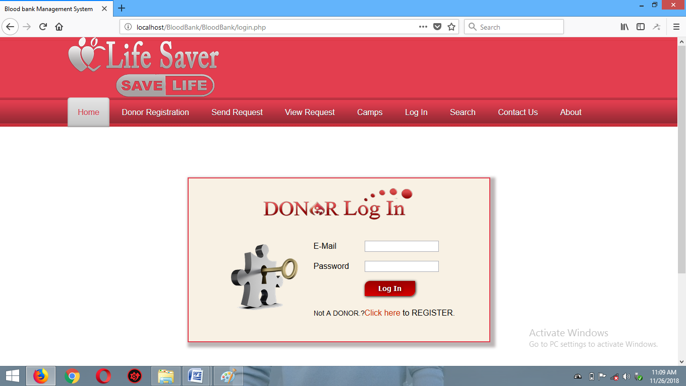

### Figure 7.5: Donor Login Page

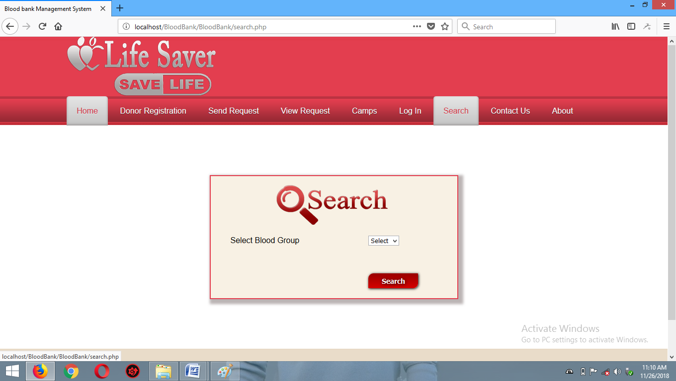

### Figure 7.6: Search Page

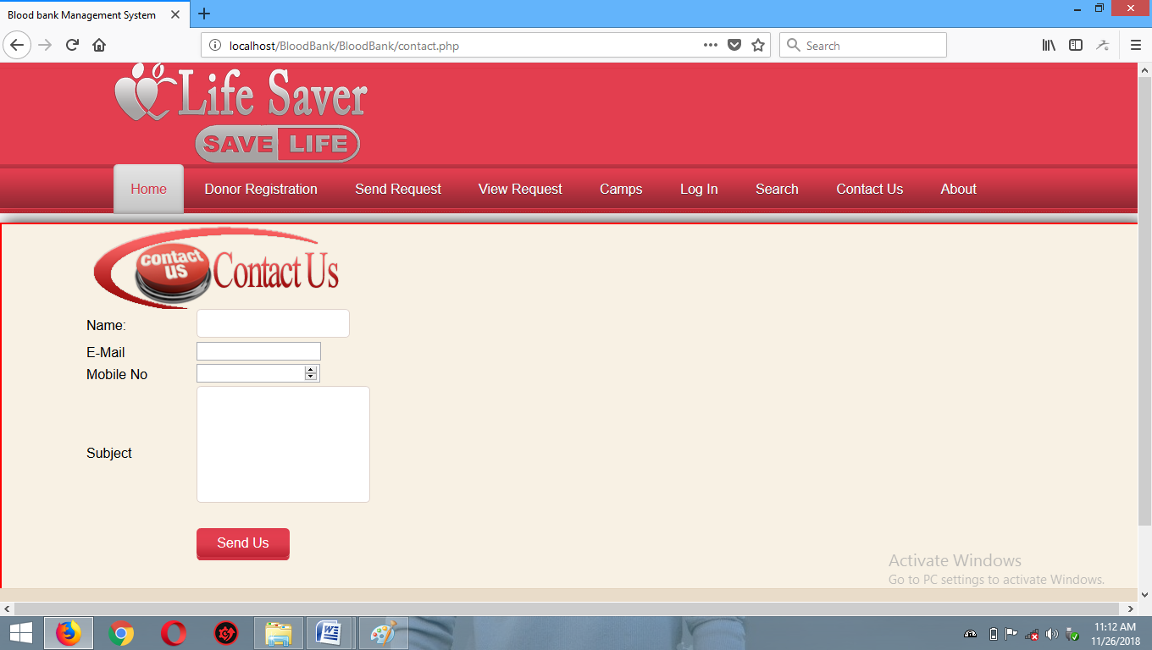

### Figure 7.7: Contact Us

## CONCLUSION

With the theoretical inclination of our syllabus it becomes very essential to take the at most advantage of any opportunity of gaining practical experience that comes along. The building blocks of this Major Project ”BLOOD BANK Management System” was one of these opportunities. It gave us the requisite practical knowledge to supplement the already taught theoretical concepts thus making us more competent as a computer engineer. The project from a personal point of view also helped us in understanding the following aspects of project development:

* The planning that goes into implementing a project.
* The importance of proper planning and an organized methodology.
* The key element of team spirit and co-ordination in a successful project.

## BIBILIOGRAPHY

[1]. [https://www.w3schools.com](https://www.w3schools.com/)

[2]. Randy Connolly, Ricardo Hoar, **“Fundamentals of Web Development”**, 1st Edition, Pearson Education India.

### [3]. Robin Nixon, “Learning PHP, MySQL & JavaScript with jQuery, CSS and HTML5”, 4th Edition, O’Reilly Publications, 2015.